
Helping Hand Worksheet

For Mounting Devices (Initial Information)

- BEFORE – As part of the evaluation, please take photos of the chair. (Refer to the
Photo Tips Sheet for the type of photos needed).
- AFTER – After you successfully install the mount, please take photos and if appropriate, have a CJT photo release signed.

In order for us to better assist you, please complete the worksheet and email it with your digital photos to: quoterequest@yescjt.com. A quote will be issued within one week.
PLEASE DO NOT FAX THE PHOTOS.

This quote should be made to:
Organization:
Today’s Date |  |  |  | Date of Next Visit
Name: (person requesting help)
Best time to contact you:
Phone Number:
Cell Number:
Email:
Address:
City/State/Zip: |  |  | ,
Client Reference Name:
(Does not have to be full name)
What type of Device
will you be mounting?
What will the mounting system be attached to? |  |  | Wheelchair  Walker  Other    Make & Model of Equipment
Is the Wheelchair |  |  | Manual  or Power
Does the chair tilt?  Is the tilt used? |  |  | YES  NO  YES  NO
Is the lap tray used on the chair? |  |  | YES  NO
Dimension of lap tray |  |  | Width Height
How does the person access their device? |  |  | Direct Select  or Switch Access  Eye Gaze  or Other  
If, Direct Select, please choose the best description of the person’s touch. |  |  | Gentle Touch  Medium touch    Strong Touch
IMPORTANT: Where does the device need to be positioned?
Will you need to order a  PFL Switch Mount?  (PFL – Profiler-Lite) If yes, please complete the PLF/PL worksheet |  |  | YES  NO
Will you need to order an additional mounting system for a second piece of equipment? |  |  | YES  NO
If YES, please complete a second worksheet and take pictures of the second piece of equipment
Special Notes
Measure from side of wheelchair seat frame up to the device.
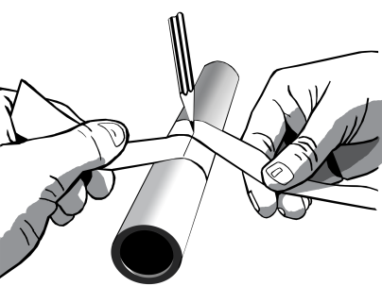 |  |  |  |  | How to measure round tubes with a strip of paper to get the “Waist Size”, i.e. the circumference.
  WAIST-SIZE (circumference) | DIAMETER  of tube
  3 3/16” | 1”
  2 3/4” | 7/8”
  2 3/8” | 3/4”
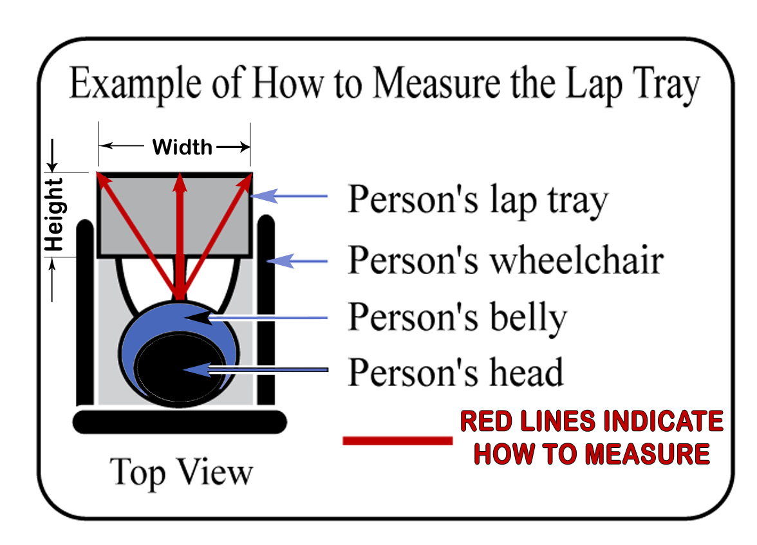 |  |  |  |  | How to Measure the Lap Tray  - Begin with the person sitting comfortably in the chair.  - Measure the width and height of the lap tray  - Measure the distance from the person’s belly to the front far edge of the lap tray.  - Measure the distance from the person’s belly towards each corner of the lap tray.

